

PCA Regional Claim System

Auto Testing with JMockit

Date Prepared:23 June 2014
Prepared By: Justin Yao

Table of Contents

1. Testing with JMockit 4
1.1. Set up environment 4
1.2. Static methods for Drools 5
1.3. Coverage report 5
1.4. Unit test case sample with JMockit 6

Related Documents
No. | Document Name | Description

Document Change Record
Document Version | Author(s) / Position | Change Reference | Date
1.0 | Justin Yao | First Release | June 03 2014

- Testing with JMockit

Set up environment
Right click on project -> properties -> Java Build Path -> Libraries-> Add JARs
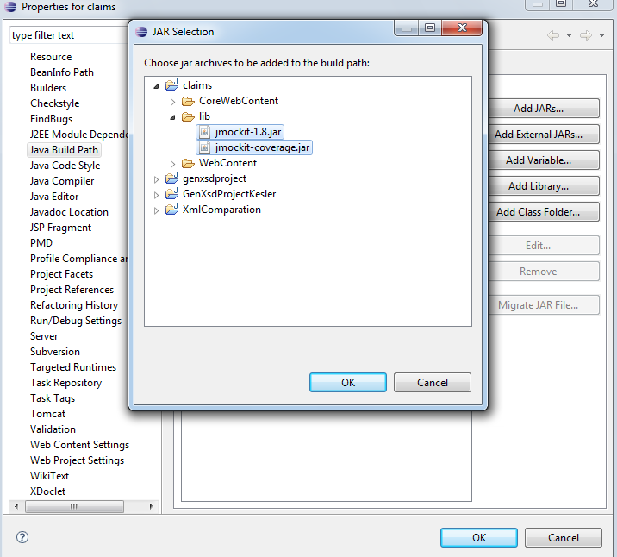
Then put jmockit-1.8.jar and jmockit-coverage.jar(if you don’t need coverage report, don’t add this jar file) in the list. These 2 jar must be placed before the jar for junit. Otherwise, the jmockit does not work.
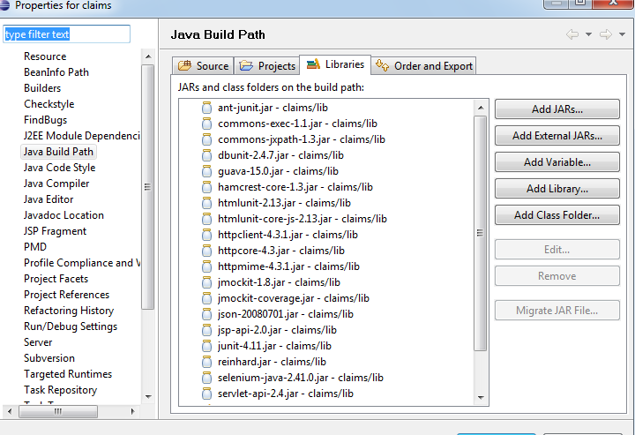

To validate the environment, run junitTestWithJmockit.xml with ant, if no error, the environment is ready.

Static methods for Drools
To do unit test on rules, for each drool file, we could extract static methods.
Take BERN_NotInExclusionPeriod.drl for example, set up a new class NotInExclusionPeriodUtil.java in package com.pca.claims.evaluation(this package path should be the same as the drools files’ package. For example, package of BERN_NotInExclusionPeriod.drl is com.pca.claims.evaluation, then the package of the new class package should also be com.pca.claims.evaluation), then create a method isNotInExclusionPeriodNAP for rule BERN_NotInExclusionPeriod_NAP, and this newly created NotInExclusionPeriodUtil.java should be in regional folder(for example PACHKsrc).
See sample NotInExclusionPeriodUtil.java in project.

Naming convention
All test case should be put in claims/test or claims/PACHKtest foder, the package keeps the same as the package of the class which will be tested.
Take NotInExclusionPeriodUtil.java as an example, it’s in folder PACHKsrc/com/pca/claims/evaluation, then we put its test cases in PACHKtest/com/pca/claims/evaluation and its test case name should be NotInExclusionPeriodUtilTest.java

Coverage report
For coverage report, generally, we don’t need to do any special configuration, just put the jmockit-coverage.jar in classpath then the coverage report will be generated automatically. If we want to control the coverage report generation, then set JVM paramters.
Here is the examples in junitTestWithJmockit.xml(See the comments for details):

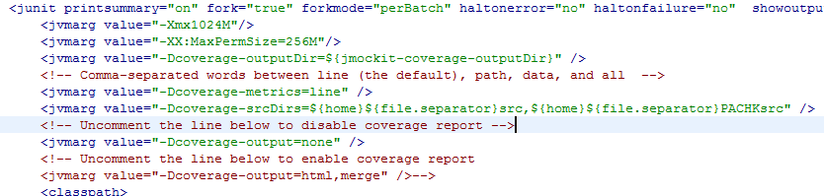

For coverage output folder
See it in junitTestBuild.properties
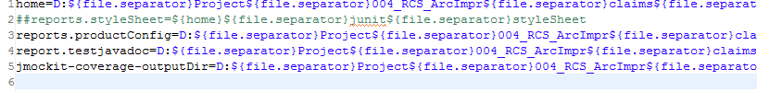

Unit test case sample with JMockit
Please see these 2 files below in project
com/pca/claims/prdconfig/producthcp/JMockitSample.java
com/pca/claims/evaluation/NotInExclusionPeriodUtilTest.java

JMockit provides APIs to support state-oriented testing(use MockUp) and behavior-based testing(use Expectations or NonStrictExpectations). According to the tutorial of JMockit: Typically, the majority of tests can be written with the Expectations & Verifications API. There are situations, however, where the Mockups API can be an useful complement to that. So for unit testing, the first choice of mocking is behavior-based testing APIs(Expectations or NonStrictExpectations). Please see code and comments in the 2 samples mentioned above to see the difference and usage.

